**Roll no:230701211**

**Exercise 5.a**

**Simulate the lifecycle stages for UI design using the RAD model**

**and develop a small interactive interface using Axure RP**

**Aim:**

The aim is to demonstrate the lifecycle stages of UI design via the RAD model and develop a small interactive interface.

**RAD Model (Rapid Application Development):** The RAD model emphasizes quick development and iteration. It consists of the following phases:

**1. Requirements Planning:**

Gather initial requirements and identify key features of the UI.

Engage stakeholders to understand their needs and expectations.

**2. User Design:**

Create initial prototypes and wireframes.

Conduct user feedback sessions to refine the designs.

Use tools like Axure RP , Figma to develop interactive prototypes.

**3. Construction:**

Develop the actual UI based on the refined designs.

Perform iterative testing and feedback cycles.

**4. Cutover:**

Deploy the final UI.

Conduct user training and support.

I designed a ecommerce app using the RAD model.

**Phase 1: Requirements Planning**

In this phase i identified the key features of my app.

The key features are:

**Navigation**

Home Screen

Product Categories

Product Details

Add to Cart

Payment

Order Confirmation

Order history

**User Actions**

Browse the Product

Add it to the Cart

Order the Product

Track the Product

Check History

This are the features of my UI design.

**Phase 2: User Design**

**Create Wireframes**

In this phase I have created a low fidelity prototype of my UI design.

I have created wireframes of the design in paper for each screen and

i added interaction and navigation flow of the design.

This is the wireframe of my ecommerce app:

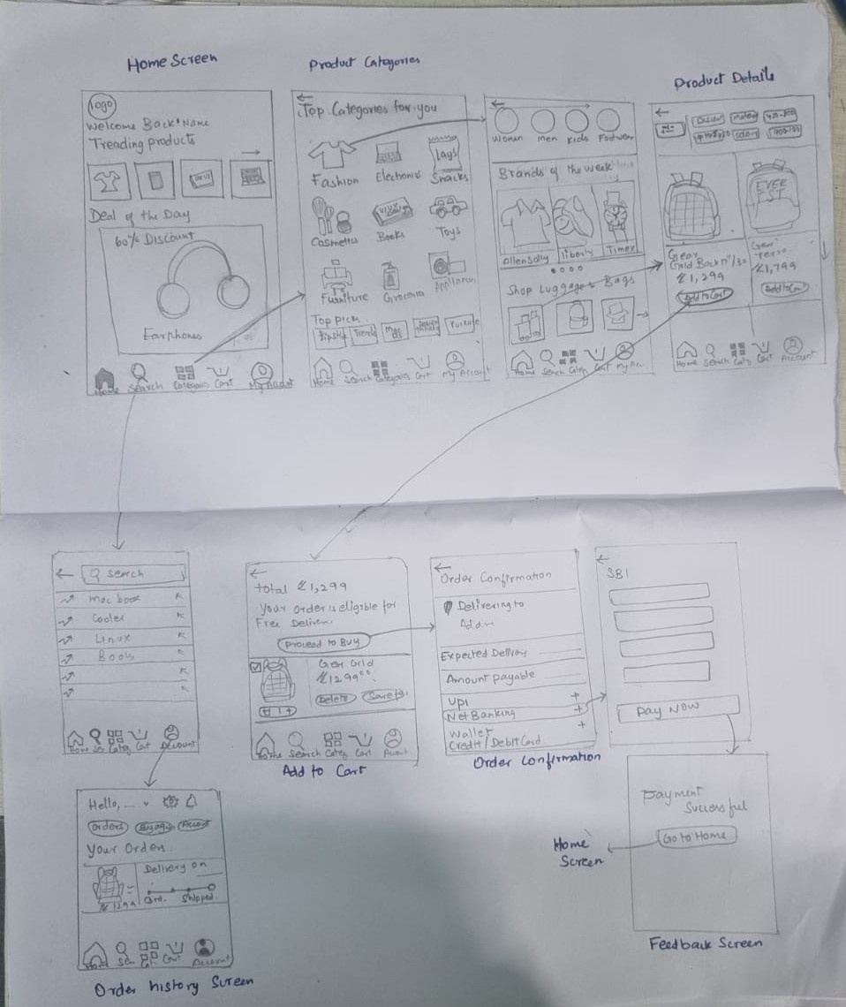

**Phase 3: Construction**

**1. Develop Interactive Prototype:**

Using Figma to develop the prototype.

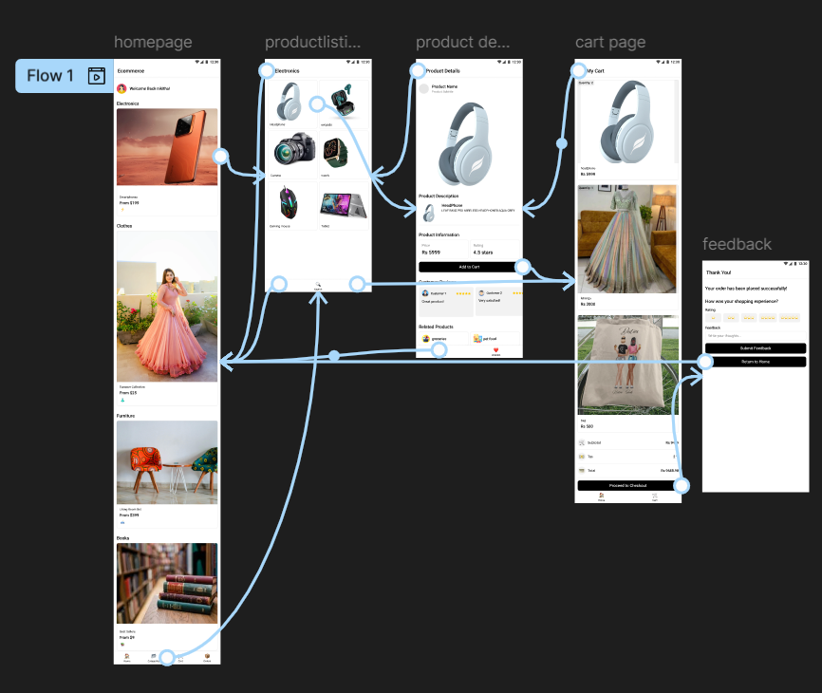

I designed a simple ecommerce app using figma and added navigation interaction.

In home page i categorized the products into electronics, cloths, furniture, books and added image for each category, then I placed the icons of home, category, cart and orders at the bottom of the page.

I used a simple layout so that users can understand it easily.

In the product listing page I listed the electronics products.

When users press electronic image in home page it goes to the product listing page.

In the product details page I have given the details of the product and add to cart option. When users press add to cart it goes cart page.

And I given a back button in every screen so that users can go to previous page.

In the cart page I given the added to cart products and total amount of the product.

And proceed to checkout button.

I designed a feedback screen for confirmation message after the pay button.

**Phase 4: cutover**

**1.Finalize and export**

I exported the prototype using share prototype.

<https://www.figma.com/proto/ktoFXA8PRwyAKGSXgPkMQQ/uid_5?node-id=6-517&t=dVuCXLyB2somW5fT-1>

**2.User training and support**

I shared the prototype with friends and family and asked them to use it. I helped them to use it and to get familiarize with the product.